*System console output:*

Person@3a6727

Person@4a65e0

*Game board output:*

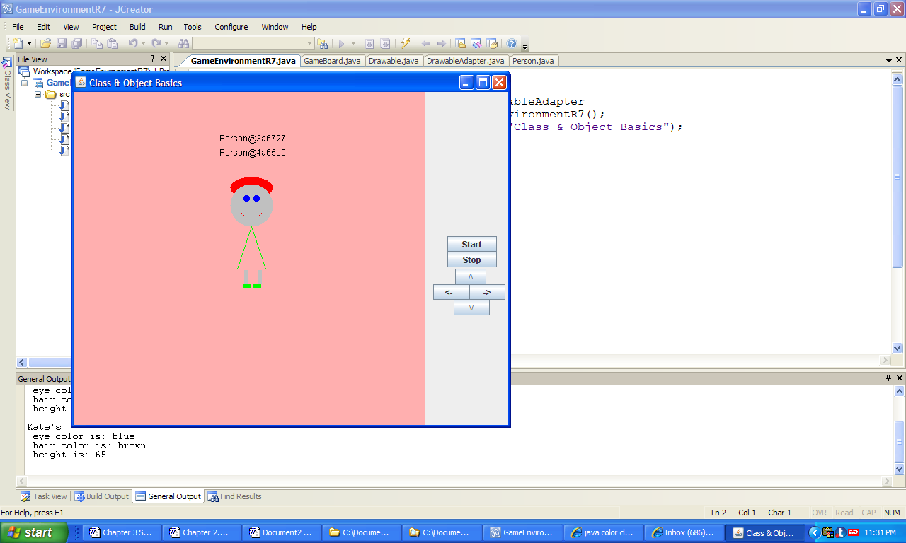

**Figure 3.15 The object locations output by the application ClassAndObjectBasics.**